### VISVESVARAYA TECHNOLOGICAL UNIVERSITY

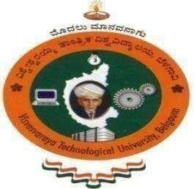**Jnana Sangama,Belgaum- 590018**

### A

**Report**

### on

“ORGANIC FARMING”

*Submitted in partial fulfillment of*

NSS ACTIVITY

*in*

COMPUTER SCIENCE AND ENGINEERING

III SEMESTER

NATIONAL SERVICE SCHEME(BNSK359)

by

S. B. Nusrath Fathima – 1HK23CS132

Under the guidance of

**Prof. Syeda Sadia Tabassum**

**Assistant Professor**

**Department of Computer Science and Engineering**

**2024-2025**

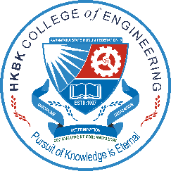

**HKBK COLLEGE OF ENGINEERING**

No.22/1, Opp., Manyata Tech Park Rd, Nagavara, Bengaluru, Karnataka 560045.

**Approved by AICTE, Affiliated by VTU & NBA Accredited**

**HKBK College of Engineering**

No.22/1, Opp., Manyata Tech Park Rd, Nagavara, Bengaluru, Karnataka 560045.

**Approved by AICTE & Affiliated by VTU & NBA Accredited**

**Department of Computer Science and Engineering**



***CERTIFICATE***

Certified that the **NSS Activity** carried out by **S. B. Nusrath Fathima** USN **1HK23CS132**, a bonafide student of **HKBK College of Engineering** in partial fulfilment for the award of Bachelor of Engineering in **Computer Science & Engineering** of the **Visvesvaraya Technological University**, Belgaum during the year 2024 - 25. It is certified that all corrections/suggestions indicated for Internal Assessment have been incorporated in the Report deposited in the departmental library.

The NSS report has been approved as it satisfies the academic requirements in respect of **NSS Activity -BNSK359** prescribed for the said Degree.

**Prof. Syeda Sadia Tabassum DR. S. Arshad Pasha**

NSS Coordinator NSS Programme Officer

**DR. Smitha Kurian DR. Mohammed Riyaz Ahmed**

HOD Principal

**DEPARTMENT OF COMPUTER SCIENCE AND ENGINEERING**

### VISION

To advance the intellectual capacity of the nation and the international community by imparting knowledge to graduates who are globally recognized as innovators, entrepreneur and competent professionals.

### MISSION

**M1.** To provide excellent technical knowledge and computing skills to make the graduates globally competitive with professional ethics.

**M2.** To involve in research activities and be committed to lifelong learning to make positive contributions to the society.

### PROGRAMME EDUCATIONAL OBJECTIVES(PEOs)

**PEO-1** To provide students with a strong foundation in engineering fundamentals and in the computer science and engineering to work in the global scenario.

**PEO-2** To provide sound knowledge of programming and computing techniques and good communication and interpersonal skills so that they will be capable of analysing, designing and building innovative software systems.

**PEO-3** To equip students in the chosen field of engineering and related fields to enable him to work in multidisciplinary teams.

**PEO-4** To inculcate in students professional, personal and ethical attitude to relate engineering issues to broader social context and become responsible citizen.

**PEO-5** To provide students with an environment for life-long learning which allow them to successfully adapt to the evolving technologies throughout their professional career and face the global challenges.

### PROGRAM OUTCOMES(POs)

1. **Engineering knowledge:** Apply the knowledge of mathematics, science, engineering fundamentals, and an engineering specialization to the solution of complex engineering problems.
2. **Problem analysis:** Identify, formulate, review research literature, and analyze complex engineering problems reaching substantiated conclusions using first principles of mathematics, natural sciences, and engineering sciences.
3. **Design/development of solutions:** Design solutions for complex engineering problems and design system components or processes that meet the specified needs with appropriate consideration for the public health and safety, and the cultural, societal, and environmental considerations.
4. **Conduct investigations of complex problems:** Use research-based knowledge and research methods including design of experiments, analysis and interpretation of data, and synthesis of the information to provide valid conclusions.
5. **Modern tool usage:** Create, select, and apply appropriate techniques, resources, and modern engineering and IT tools including prediction and modeling to complex engineering activities with an understanding of the limitations.
6. **The engineer and society:** Apply reasoning informed by the contextual knowledge to assess societal, health, safety, legal and cultural issues and the consequent responsibilities relevant to the professional engineering practice.
7. **Environment and sustainability:** Understand the impact of the professional engineering solutions in societal and environmental contexts, and demonstrate the knowledge of, and need for sustainable development.
8. **Ethics:** Apply ethical principles and commit to professional ethics and responsibilities and norms of the engineering practice.
9. **Individual and team work:** Function effectively as an individual, and as a member or leader in diverse teams, and in multidisciplinary settings.

1. **Communication:** Communicate effectively on complex engineering activities with the engineering community and with society at large, such as, being able to comprehend and write effective reports and design documentation, make effective presentations, and give and receive clear instructions.
2. **Project management and finance:** Demonstrate knowledge and understanding of the engineering and management principles and apply these to one’s own work, as a member and leader in a team, to manage projects and in multidisciplinary environments.
3. **Life-long learning:** Recognize the need for, and have the preparation and ability to engage in independent and life-long learning in the broadest context of technological change

### PROGRAM SPECIFIC OUTCOMES (PSOs)

1. Problem-Solving Skills: An ability to investigate and solve a problem by analysis, interpretation of data, design and implementation through appropriate techniques, tools and skills.
2. Professional Skills: An ability to apply algorithmic principles, computing skills and

computer science theory in the modelling and design of computer-based systems.

1. Entrepreneurial Ability: An ability to apply design, development principles and management skills in the construction of software product of varying complexity to become an entrepreneur.

### ACKNOWLEDGEMENT

We would like to place our regards and acknowledgement to all who helped in making this project possible. There are many people who worked behind the screen to help make it possible the below listed are a few of them.

We would take this opportunity to express our heartfelt gratitude to  
**Mr. C. M. Ibrahim**, Chairman, **Mr. C. M. Faiz Mohammed**, Director and **Dr. Mohammed Riyaz Ahmed**, Principal for all the infrastructure provided to complete the activity on time.

We are deeply indebted to **DR.** **Smitha Kurian, Professor & Head**, Computer Science and Engineering for the in effable encouragement provided in successful completion of the project.

A special and an earnest word of thanks to the department NSS coordinator **Prof. SA Tanveer RazAssistant Professor**, Dept of CSE, for his constant assistance, support, patience, endurance and constructive suggestions for the betterment of the project.

We are extremely thankful to the teaching and non-teaching staff of the **Department of Computer Science and Engineering** for their valuable guidance and cooperation throughout our dissertation.

S. B. Nusrath Fathima – 1HK23CS132

The National Service Scheme (NSS) is a flagship youth program in India aimed at fostering social responsibility, personal development, and community engagement among students. Established in 1969 under the Ministry of Youth Affairs and Sports, NSS operates on the principle of "Not Me but You," emphasizing selfless service and volunteerism.

NSS engages students in various community service activities, ranging from environmental conservation and healthcare initiatives to literacy programs and socio-economic development projects. Through these endeavors, students not only address the needs and challenges of local communities but also develop a sense of empathy, responsibility, and leadership.

Moreover, NSS serves as a platform for youth empowerment, encouraging students to become active agents of positive change in society. By providing opportunities for skill development, leadership training, and hands-on experience, NSS equips students with the tools and mindset needed to tackle real-world issues and make meaningful contributions to their communities.

One of NSS's key objectives is to promote national integration and unity by bringing together students from diverse backgrounds and fostering mutual understanding and respect. Through collaborative efforts and interactions with peers from different regions and cultures, NSS helps bridge social divides and promote harmony.

Additionally, NSS plays a vital role in education and awareness, organizing campaigns on various social issues such as health, hygiene, environmental sustainability, and civic responsibilities. By spreading knowledge and information, NSS aims to create awareness and promote positive behavioral changes in society.

Overall, NSS serves as a catalyst for holistic development, empowering youth to become socially conscious and actively engaged citizens committed to making a positive impact on their communities and the nation as a whole.

## TABLE OF CONTENTS

|  |  |  |
| --- | --- | --- |
| **Chapter No.** | **Chapter Title** | **Page No** |
|  | **ACKNOWLEDGEMENT** | **iv** |
|  | **ABSTRACT** | **v** |
| **1** | **INTRODUCTION TO NSS** | **7** |
| **2** | **INTRODUCTION TO WASTE MANAGEMENT** | **11** |
|  |  |  |
| **3** | **ACTIVITY: NSS ORGANIC FRAMING** | **18** |
|  |  |  |
|  | **CONCLUSION** | **21** |
|  | **REFERENCES** | **22** |

### CHAPTER1

##### INTRODUCTION TO NSS

The National Service Scheme, popularly known as NSS, stands as a beacon of youth empowerment and societal development in India. Envisioned as a platform to instill the values of community service, social responsibility, and national integration among the youth, NSS has evolved into one of the largest voluntary organizations in the world. With its roots embedded in the ethos of Mahatma Gandhi's philosophy of selfless service, NSS epitomizes the spirit of volunteerism and activism, catalyzing positive change across the nation.

Established on September 24, 1969, under the Ministry of Youth Affairs and Sports, Government of India, NSS operates on the principle of "Not Me But You," emphasizing collective action for the betterment of society. The scheme operates at the university, college, and school levels, engaging millions of students in various community development activities. NSS functions through a network of institutions, with designated Program Coordinators overseeing the implementation of its initiatives.

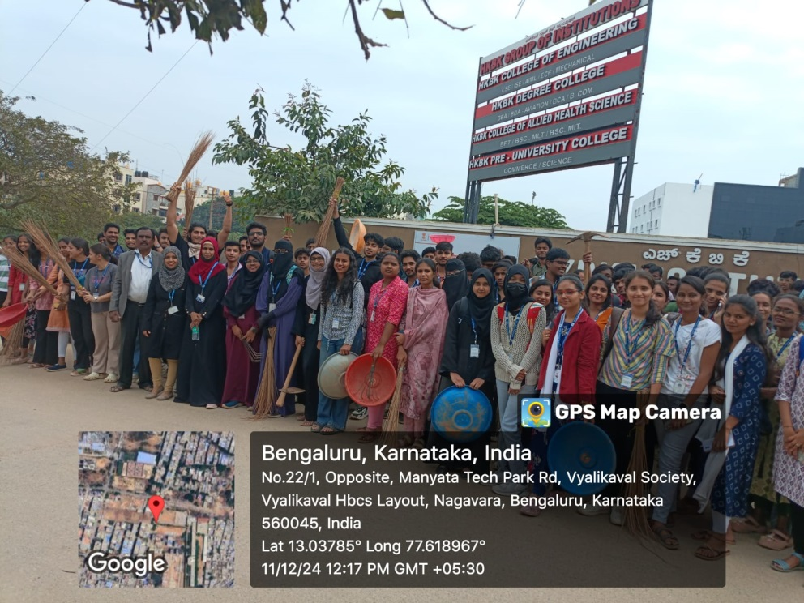

**Fig 1.1: National Service Scheme.**

* 1. **Motto of NSS:**

The motto of the National Service Scheme (NSS) is "Not Me But You." This motto reflects the essence of selfless service and the spirit of volunteerism that underpins the NSS program. It emphasizes the idea of putting the needs of others before one's own and working towards the betterment of society as a collective effort. The motto encapsulates the philosophy of altruism and social responsibility that guides the activities and initiatives undertaken by NSS volunteers.

**1.2 Objectives of NSS:**

The National Service Scheme (NSS) typically operates under the motive of promoting social welfare and development through community service and volunteering activities. Here are some of the main motives of NSS:

• **Community Development:** NSS aims to engage students in various community development projects such as sanitation drives, literacy campaigns, health awareness programs, and environmental conservation efforts. The goal is to contribute to the overall improvement of society.

• **Youth Empowerment:** NSS provides a platform for young people to develop leadership skills, teamwork, and a sense of social responsibility. Through participation in NSS activities, students gain practical experience and learn the value of serving others.

• **National Integration:** NSS fosters unity and understanding among people from diverse backgrounds by encouraging interactions and collaborations between students belonging to different regions, cultures, and socio-economic backgrounds.

• **Education and Awareness:** NSS organizes educational and awareness campaigns on various social issues such as healthcare, hygiene, environmental sustainability, and civic responsibilities. By spreading knowledge and information, NSS aims to bring about positive behavioral changes in society.

• **Character Building:** Participation in NSS activities helps in the holistic development of students by instilling values such as empathy, compassion, and altruism. Through service to others, students learn to become responsible citizens and contribute positively to the welfare of society.

* 1. **Introduction to NSS**

At its core, NSS aims to foster the holistic development of students by nurturing their sense of civic engagement and social responsibility. Through a diverse range of activities encompassing health, education, environment, and social welfare, NSS endeavors to address the multifaceted challenges faced by communities across the country. From organizing blood donation camps and cleanliness drives to conducting awareness campaigns on issues like literacy, gender equality, and environmental conservation, NSS volunteers actively contribute to nation-building.

The impact of NSS extends far beyond the tangible outcomes of its projects. By providing a platform for youth from diverse backgrounds to collaborate and work towards common goals, NSS promotes inter-cultural understanding and national unity. Volunteers learn valuable life skills such as leadership, communication, and teamwork, which are instrumental in their personal and professional growth. Moreover, the exposure to real-world challenges sensitizes them to the socio-economic realities of the communities they serve, fostering empathy and compassion.

NSS also plays a pivotal role in supplementing government initiatives in areas like healthcare, education, and rural development. By mobilizing youth manpower and resources, NSS complements the efforts of governmental and non-governmental organizations, amplifying the impact of social welfare programs. The symbiotic relationship between NSS and other stakeholders strengthens the fabric of civil society, facilitating inclusive development and social justice.

Beyond its domestic endeavors, NSS actively participates in international collaborations and exchange programs, promoting global citizenship and cross-cultural learning. Through partnerships with foreign universities and organizations, NSS exposes its volunteers to diverse perspectives and best practices in community development, enriching their understanding of global issues and solutions. The success of NSS hinges on the unwavering commitment and enthusiasm of its volunteers, who selflessly dedicate their time and energy towards the service of others. Whether it's braving adverse weather conditions to conduct vaccination drives in remote villages or organizing relief efforts during natural disasters, NSS volunteers exemplify the spirit of altruism and resilience.

In conclusion, the National Service Scheme embodies the ethos of youth empowerment, social justice, and nation-building. With its expansive reach, diverse initiatives, and unwavering dedication to the welfare of society, NSS continues to inspire generations of young Indians to be agents of positive change. As we navigate the complexities of the modern world, the values instilled by NSS - empathy, solidarity, and service above self - remain indispensable in shaping a more equitable and compassionate society.

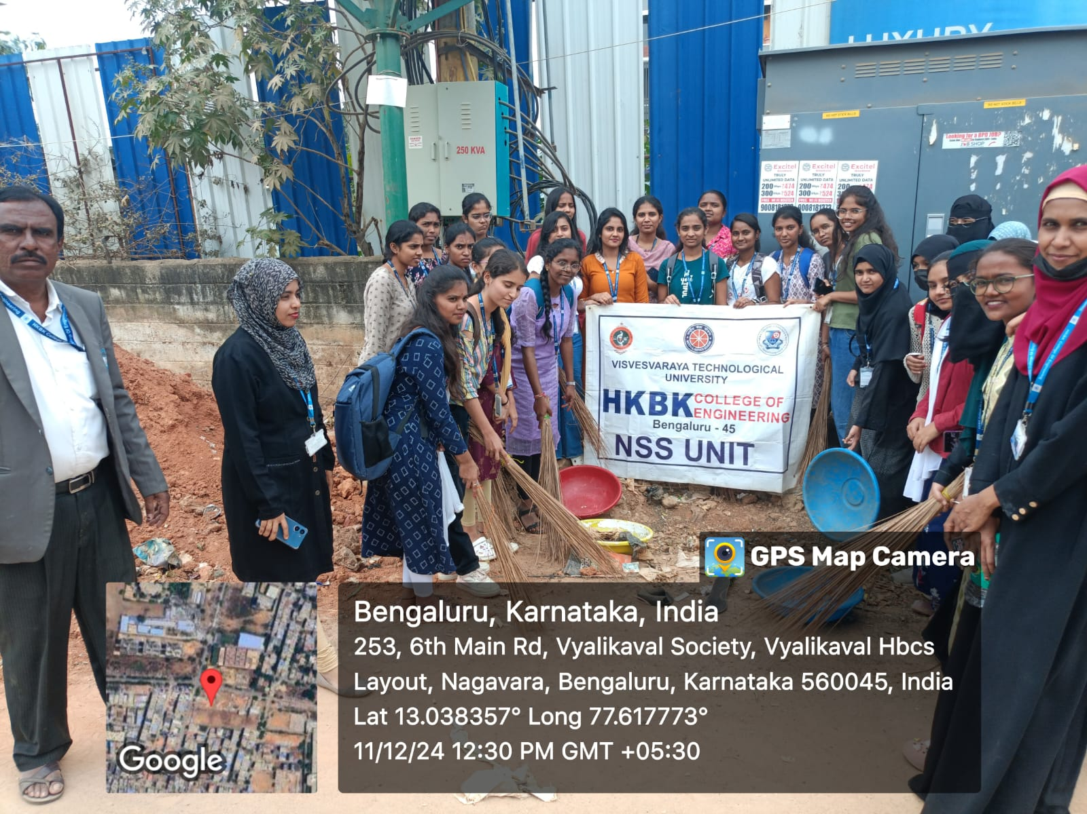

**Fig 1.2: Guidelines regarding National Service Scheme.**

### CHAPTER 2

**INTRODUCTION TO WASTE-MANAGEMENT**

Waste management is a critical aspect of sustainable development, encompassing the collection, disposal, recycling, and treatment of waste materials. In the agricultural sector, waste management involves dealing with organic waste such as crop residues, animal manure, and packaging materials. Effective waste management strategies require collaboration between public, private, and government organizations to minimize environmental pollution, conserve resources, and create value from waste streams.

**2.1 Public, Private, and Government Organizations:**

Public organizations such as municipal authorities and waste management boards play a key role in waste collection, segregation, and disposal at the local level. Private companies are involved in waste processing, recycling, and waste-to-energy initiatives. Government agencies set regulations, provide incentives, and support research and development in waste management technologies and practices.

**2.1 Organic farming**

Organic farming involves agricultural practices that prioritize environmental sustainability, biodiversity, and animal welfare. It avoids the use of synthetic fertilizers, pesticides, and genetically modified organisms. In India, organic farming has gained momentum due to growing concerns about chemical residues in food, environmental degradation, and the sustainability of conventional farming practices. The adoption of organic farming offers numerous benefits such as improved soil health, conservation of natural resources, and premium prices for organic produce in domestic and international markets.

**2.1.1 Waste Management Practices**

**1. Public Sector Initiatives:**

* Municipal waste collection and disposal.
* Recycling programs in urban areas.
* Awareness campaigns for waste segregation.

**2. Private Sector Contributions:**

* Corporate responsibility programs for waste reduction.
* Innovative waste recycling solutions.
* Collaboration with local communities for sustainable waste management.

**3. Government Organizations' Role:**

* Policy formulation for waste management.
* Monitoring and enforcement of waste disposal regulations.
* Investment in research for advanced waste treatment technologies.

**2.2 The 5 R's Approach:**

The 5 R's approach—Reduce, Reuse, Recycle, Recover, and Residual Management—is a framework for sustainable waste management. It emphasizes minimizing waste generation through efficient resource use, promoting reuse and recycling to extend the life of materials, recovering energy from waste, and managing residual waste responsibly. Implementing the 5 R's requires awareness campaigns, infrastructure investments, policy support, and stakeholder collaboration.

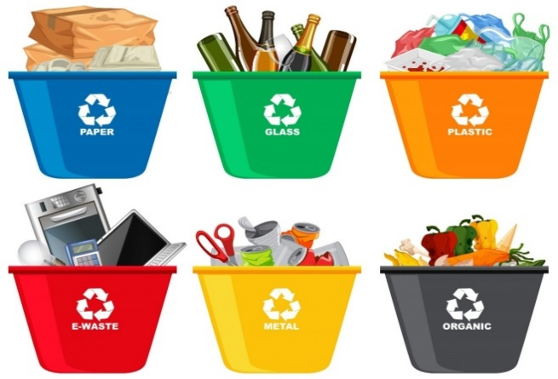

**Fig 2.1: Waste Management.**

**2.2.1 R’s of Waste Management:**

* **Reduce:** Minimizing waste production at the source.
* **Reuse:** Encouraging the use of products multiple times.
* **Recycle:** Processing waste materials into new products.
* **Recover:** Extracting energy from waste through incineration or anaerobic digestion.

**Rethink:** Promoting a shift in consumer behavior towards sustainability.

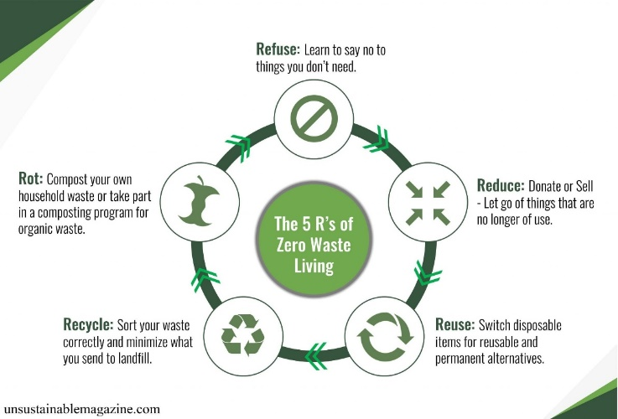

**Fig 2.2: 5R’s for healthy earth.**

Waste management is a critical aspect of maintaining environmental sustainability and public health. Effective waste management involves the collection, transportation, processing, and disposal of waste materials in a manner that minimizes environmental impact and maximizes resource recovery. This report will discuss the importance of waste management, current challenges, and potential solutions to improve waste management practices.

**2.3 Importance of Waste Management:**

**1. Environmental Protection:** Proper waste management helps prevent pollution of air, water, and soil, preserving ecosystems and biodiversity.

**2. Public Health**: Inadequate waste management can lead to the spread of diseases and pose health risks to communities.

**3. Resource Conservation:** Recycling and reusing waste materials reduce the demand for raw materials, conserving natural resources and energy.

**4. Economic Benefits:** Efficient waste management systems can generate revenue through recycling, waste-to-energy processes, and the creation of green jobs.

**2.3.1 Current Challenges:**

**1. Inadequate Infrastructure:** Many regions lack proper waste collection and disposal infrastructure, leading to illegal dumping and pollution**.**

**2. Limited Awareness:** Lack of awareness about waste segregation, recycling, and proper disposal practices contributes to improper waste management.

**3. Growing Waste Generation:** Rapid urbanization and population growth have led to an increase in waste generation, straining existing waste management systems.

**4. Pollution and Health Risks:** Improperly managed waste can contaminate water sources, release harmful gases, and attract pests, posing health risks to humans and wildlife.

**2.3.2 Potential Solutions:**

**1. Integrated Waste Management:** Implementing a holistic approach that includes waste reduction, recycling, composting, and waste-to-energy technologies can minimize waste sent to landfills.

**2. Public Education and Awareness:** Promoting waste segregation at the source, educating communities about the benefits of recycling, and encouraging sustainable consumption habits can improve waste management practices.

**3. Infrastructure Development:** Investing in modern waste collection, treatment, and disposal facilities, as well as establishing efficient transportation networks, is essential for effective waste management.

**4. Policy and Regulation:** Enforcing strict regulations on waste disposal, imposing penalties for illegal dumping, and incentivizing businesses to adopt sustainable waste management practices can drive positive change.

**5. Innovation and Technology:** Research and development of innovative technologies such as waste sorting robots, advanced recycling processes, and biodegradable packaging can enhance waste management efficiency and effectiveness.

### CHAPTER 3

**ACTIVITY: NSS ACTIVITY ORGANIC FRAMINGH AT HKBK CAMPUS**

The Enrichment Program for HKBK College of Engineering students, organized as a National Service Scheme (NSS) activity, aimed to provide students with additional learning opportunities beyond their regular curriculum. This program was designed to enhance their academic skills, foster personal development, and promote a culture of community service among the youth. The program commenced on **11TH DECEMBER** and spanned **from 09:30 am to 03:00 pm**.

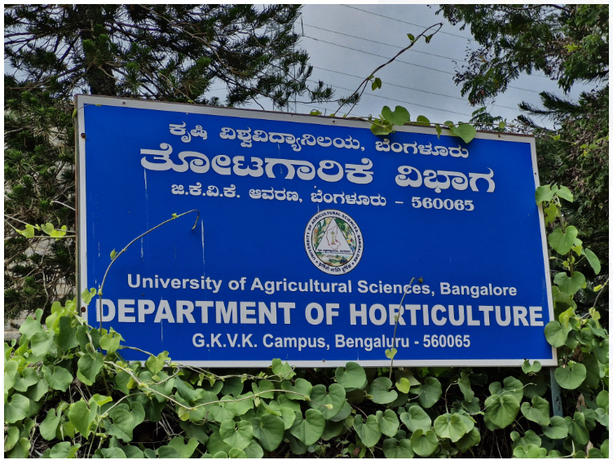

##### 

##### ORGANIC FARMING

##### C:\Users\Admin\Downloads\mazu.jpg

**4.1 Objectives:**

The Enrichment Program had the following objectives:

* **Academic Enhancement:** To provide supplementary educational support to students in key subjects such as Mathematics, Science, English, and Social Studies, thereby improving their academic performance.
* **Personal Development:** To cultivate essential life skills such as communication, teamwork, problem-solving, and leadership among the students, empowering them for future success.
* **Cultural and Artistic Enrichment:** To expose students to diverse cultural experiences, arts, and creative expression, fostering their appreciation for the arts and promoting cultural inclusivity.
* **Community Engagement:** To instill a sense of social responsibility and civic engagement among students through participation in community service activities and initiatives.

**4.2 Activities Undertaken:**

Throughout the duration of the program, a variety of activities were organized to fulfill its objectives:

* **Academic Workshops:** Regular workshops and tutoring sessions were conducted by volunteers and qualified educators to provide academic support in core subjects. These sessions focused on clarifying concepts, solving practice exercises, and preparing students for exams.
* **Life Skills Training:** Workshops and interactive sessions were organized to impart essential life skills such as communication, time management, decision-making, and conflict resolution. Role-playing activities and group discussions facilitated experiential learning.
* **Cultural and Artistic Workshops:** Students were exposed to various forms of art, music, dance, and theater through workshops and performances conducted by guest artists and experts. These sessions encouraged creativity, self-expression, and cultural appreciation.
* **Community Service Projects:** Students actively participated in community service projects such as cleanliness drives, tree plantation initiatives, awareness campaigns on social issues, and volunteering at local NGOs.

**4.3 Impact and Outcomes:**

The Enrichment Program yielded several positive outcomes for the participating students:

* **Academic Improvement:** Many students showed noticeable improvement in their academic performance, especially in subjects where they received additional support and guidance.
* **Personal Growth:** Students demonstrated enhanced confidence, communication skills, and teamwork abilities through their participation in workshops and interactive sessions.
* **Cultural Awareness:** Exposure to diverse cultural experiences and artistic activities broadened students' horizons and fostered a deeper appreciation for cultural diversity.
* **Community Engagement:** Students developed a sense of empathy, social responsibility, and civic pride through their involvement in community service projects, realizing the importance of contributing positively to society.

**4.4 Challenges and Future Plans:**

Despite its successes, the Enrichment Program encountered certain challenges, including logistical constraints and limited resources. To address these challenges and further improve the program, the following future plans have been proposed:

* **Sustainability:** Implementing measures to ensure the sustainability of the program, including securing long-term funding, recruiting dedicated volunteers, and establishing partnerships with educational institutions and community organizations.
* **Expansion:** Expanding the scope and reach of the program to benefit a larger number of students from diverse backgrounds and geographical areas.d geographical areas.



##### 

##### Fig 4.2: Cleaning Nearby Areas of College Campus

##### CONCLUSION

In conclusion, addressing the challenges related to education, water management, and socio-economic development requires a multi-dimensional approach involving government intervention, community participation, and collaboration with various stakeholders. By implementing strategies to improve local schools, develop sustainable water management systems, and contribute to national initiatives, India can pave the way for inclusive growth, environmental sustainability, and socio-economic empowerment at the grassroots level.

Sustainable rural development and agriculture enhancement are imperative for addressing poverty, food security, and environmental sustainability challenges. By promoting organic farming, improving market connectivity, implementing waste management strategies, empowering women, conserving water resources, and fostering entrepreneurship, rural communities can achieve holistic development and prosperity. Effective collaboration between government, private sector, civil society, and local communities is essential for realizing the vision of inclusive and sustainable rural development in India.

### REFERENCES

* 1. Arbor Day Foundation: https://www.arborday.org/
  2. U.S. Forest Service: https://www.fs.fed.us/treesearch/
  3. The Morton Arboretum: https://www.mortonarb.org/trees-plants
  4. American Forests: https://www.americanforests.org/
  5. US Environmental Protection Agency: https://www.epa.gov/water-research/water-conservation
  6. National Wildlife Federation: https://www.nwf.org/Educational-Resources/Wildlife-Guide/Water/WaterConservation
  7. Alliance for Water Efficiency: https://www.allianceforwaterefficiency.org/
  8. The Water Project: https://thewaterproject.org/water-conservation
  9. Water Use It Wisely: https://www.wateruseitwisely.com/
  10. USDA National Organic Program: https://www.ams.usda.gov/grades-standards/organic-standards
  11. Organic Farming Research Foundation: https://ofrf.org